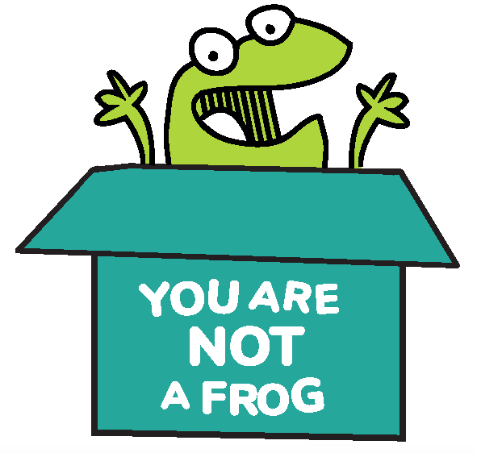
You Are Not A Frog

Workbook, CPD & Reflection Log

Episode 61: The Self Help Book Group On Happiness with Dr Nik Kendrew

For this episode, Rachel is joined by Dr Nik Kendrew, a GP, fellow podcaster and an all round wise guy. Nik and Rachel talk about the books they have been reading and the concept of happiness. They discuss the difference between the height and depth of happiness, how the smallest of experiences can shape us and the small things that can make a huge difference in our happiness levels.

Nik also talks about his confrontation with death after not getting the job he was looking forward to, and how that experience changed his life and encouraged him to reach for his dreams.

Podcast links  - You Are Not A Frog Ep. 17 with Dr Nik Kendrew  - You Are Not A Frog Ep. 49 with Dr Nik Kendrew  - The Midnight Library by Matt Haig  - Reasons to Stay Alive by Matt Haig | - Happier: Learn the Secrets to Daily Joy and Lasting Fulfillment by Tal Ben Shahar  - Happy, directed by Roko Belic  - Boggled Docs, a podcast by Nik Kendrew:  - Follow Nik on Twitter | - Sign up here for more FREE resources.  - Join the Shapes Collective Facebook group.  - Email Rachel or reach her on LinkedIn or Twitter.  - Get our special Beat Stress and Thrive E-Course For Health Professionals Christmas 2020 offer.

QUOTE TO REMEMBER:

‘Don't wait; try things now. Live in the present. Don't worry about the future or the past and appreciate those little things’.

What You Will Learn From The Activity

There’s something different about reading a book in contrast with watching something on a screen. Books can be really powerful tools for us to learn lessons from. In the episode, Rachel and Nik shared two books that opened up an insightful discussion on happiness, perfectionism, regrets, and living in the moment.

This activity aims to let you reflect on your definition of happiness, doing what excites you and understanding what it means to be truly alive. It also aims to give you time to evaluate your past decisions and experiences and how they influence your life and actions.

As we deal with a global pandemic and economic crisis, happiness seems so fleeting, something incredibly hard to achieve. But now is also the perfect time to learn to be content and appreciate what you have and how you got to where you are.

Activity: What It Means To Be Truly Alive

What are your key takeaways from this episode?

Have you recently read any book that taught you a lesson on happiness and the other themes in this week’s episode?

What were the things you learned from the book(s) you read?

How do you relate to Nora in The Midnight Library? Write your thoughts or experiences below.

Why did Matt Haig say that a person is like a city? Do you agree with him? How so?

‘I think I've often heard people say that where we go wrong is that we think of happiness as a destination. But it's actually everything that happens along the way to that — that's the most important stuff’. Do you agree with this statement? Why or why not?

What is the difference between the heights and depths of happiness?

Are there moments or decisions you’ve made that you perhaps wish didn't happen but were pivotal for your self-development?.

Concerning the previous question, what are the learnings you obtained from that experience?

How do you define happiness? What makes you happy, excited, and alive?

Are you happy with what you are doing right now? If not, what are the factors that are holding you back from achieving your dreams?

How do fear and perfectionism prevent us from being truly happy?

Which of Nik’s and Rachel’s tips for living in the present and being happier chimed with you?.

CPD time claimed:

For more episodes of You are not a frog, check out our website www.youarenotafrog.co.uk follow Rachel on Twitter @DrRachelMorris and find out more about her online and face to face courses on surviving and thriving at work at www.shapestoolkit.com.

