You Are Not A Frog

CPD & Reflection Log

Episode 34:

Podcast notes
This week Rachel chats with Gitanjali Trevorrow-Seymour A self confessed neuroscience nerd, Gitanjali is on a mission to liberate our brains. As The Possiblist Coach she increases her client's resilience, confidence and impact; liberating them from overthinking so they are empowered to see what's possible. She is also the Founder of the leadership development company, High Definition You. If you’d like to see the slide on social styles then why don’t you watch this episode on YouTube? (insert link)

In the COVID crisis you may be trying to be kind and make allowances for people, but it’s hard! We chat about how we can all act in stressful situations – becoming an ‘uber’ version of, if we’re honest, not always our best selves.

Gita uses the social styles model to talk through a simple way of thinking about how we behave and respond to others in our teams and families. Some of us assert our opinion more easily than others and some of us are able to control how we express things and are perhaps more task focussed than others. This shows up in how we interact – and crucially how people clash under pressure.
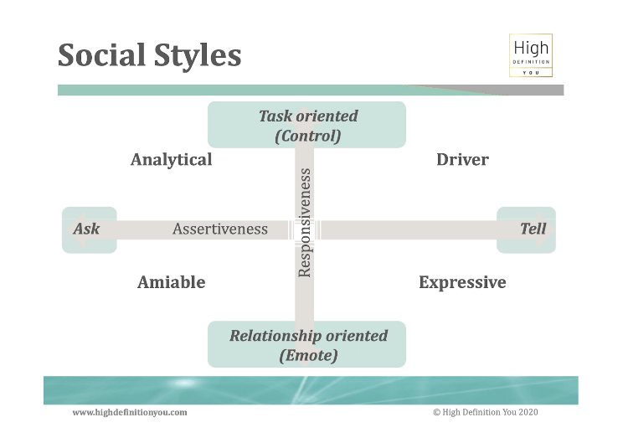

We discuss the different styles and chat about how we can change our own behaviour to get the best out of people.
Gita’s top tips are:
- Be kind to yourself
- Create some time to reflect on yourself and how you are experienced?
- Seek out some feedback from others about how you are experienced by them
We are sending out a weekly email with new resources, tips and useful content especially for doctors and healthcare professionals throughout the COVID-19 crisis. If you’d like to receive this and other resources about thriving at work then please sign up here

You can watch this podcast episode on YouTube here (where you can also see the social styles slide)

Podcast links

Get the COVID Team Wellbeing Toolkit which includes instructions on how to run a team check in chat here

Website: http://highdefinitionyou.com
For personal self coaching tips go to: http://highdefinitionyou.com/videos
To be the first to know about what's coming up next from Gitanjali go to: http://highdefinitionyou.com/waitlist
Gita is launching a brand new group coaching programme – find it here

https://highdefinitionyou.com/80daysregister/

To get weekly top tips and inspiration go to: https://highdefinitionyou.com/yesplease/
LinkedIn: https://www.linkedin.com/in/linkinwithgitanjali/
Instagram: https://www.instagram.com/gitanjali_hdyou/
Facebook: https://www.facebook.com/highdefinitionyou/

24 hour support for NHS staff: Call 0300 131 7000 between 7am and 11pm or text FRONTLINE to 85258 24/7.

BMA Wellbeing Service
The NHS Practitioner Health Programme

Sign up for downloadable CPD reflection forms plus more tools and resources

For more episodes of You are not a frog, check out our website You Are Not A Frog Podcasts and sign up to our mailing list here for loads of useful resources about thriving at work. You can also join the Shapes Collective Facebook group where we chat about the hot topics and regularly post interesting articles
Follow Rachel on twitter @DrRachelMorris or LinkedIn and find out more about her online and face to face courses for doctors on surviving and thriving at work at www.shapesfordoctors.com or for other organisations at www.shapestoolkit.co.uk

What three key things have you learned from listening to this podcast?

Is there anything you can use from this podcasts that will help you to help others?

What are you going to do now?
How will you know if this has made a difference?
CPD time claimed:

For more episodes of You are not a frog, check out our website www.shapesfordoctors.com/podcasts follow Rachel on twitter @DrRachelMorris and find out more about her online and face to face courses on surviving and thriving at work at www.shapesfordoctors.co.uk

Get more reflection forms and useful stuff about thriving at work by signing up to the Shapes Collective Facebook Page.

