Episode 132: What to Do When You Are Overwhelmed
with Gerrie Hawes
For doctors and other professionals in high-stress jobs, your tasks and responsibilities seem endless. Some might even choose to forsake your personal time because you're too busy. Unfortunately, being overwhelmed by what you need to do is common and can often lead to burnout.

No one wants to feel overwhelmed. Fortunately, Gerrie Hawes joins Rachel in this episode to talk about what you can do when you start feeling overwhelmed. With just six steps, take control of your life and don't let yourself drown in your to-do list.

If you’re starting to feel overwhelmed, listen to the full episode to find out what you can do to stop it.

Podcast links

Feeling overwhelmed right now? Download our Overwhelm Buster Toolkit here.

Get a copy of the Virtual Fatigue Buster Toolkit

Feeling overwhelmed? Reach out to Rachel at hello@youarenotafrog.com

THRIVE Weekly Planner

Check out our Permission to Thrive CPD membership for doctors
Find out more about the Shapes Toolkit training, talks and workshops
Sign up here for more free resources
Join the Shapes Collective FB group.
Email Rachel or reach her on LinkedIn or Twitter.

Guest links

Connect with Gerrie: LinkedIn | Email | Website

Quote to remember:
‘You know all those things that you're supposed to be doing to look after your well-being, contentment and happiness. At the end, add that into your to-do list and decide where you're going to prioritize it.’

What You Will Learn
Unfortunately, feeling overwhelmed is a common experience for many professionals in high-stress jobs. It’s difficult to do your best when you constantly feel like it’s too much. However, this doesn’t make you weak. Instead, realize that you have the control to be able to turn your overwhelming situation around.

You can make significant changes when you take responsibility for your happiness. Learn to actively do more of what makes you happy in your daily life: have a cup of tea, or take that quick break.

At some point, you might stop and realize that you're starting to feel overwhelmed. The six steps in the activity teach you to rise above this feeling. With the help of others, you can successfully plan out all that you need to do in the next week. Learn to delegate, delay or stop tasks that aren't urgent. You can also start including your self-care activities in your priorities.

The activity teaches you that you don't have to let yourself get swept up by all the unending tasks. With proper planning, help and an optimistic mindset, you can pursue happiness at work and outside it. Stop being overwhelmed and start enjoying what you do.

Activity: You VS Overwhelming Work
The things you need to do might look overwhelming. However, you control what you do in a day. Take responsibility for your happiness. What enjoyable activities can you start doing daily?
- ____________________________________________________________
- ____________________________________________________________
- ____________________________________________________________
- ____________________________________________________________
- ____________________________________________________________

Be optimistic and work towards your vision. In the space below, use the pie chart to show how you want to use your 24 hours. In the second pie chart, describe how your typical day looks.

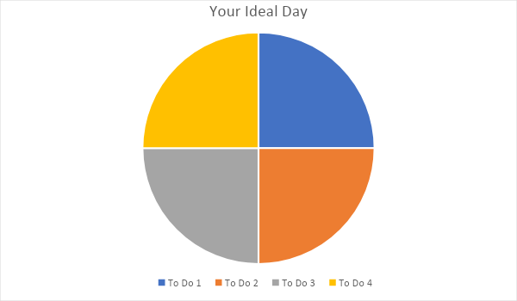

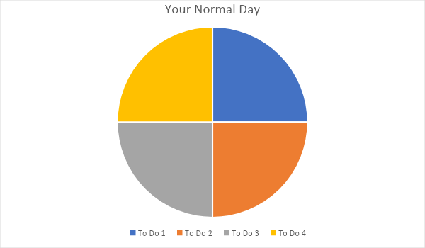

Compare your ideal day vs your typical day. How do they differ?

Is your typical day sustainable? How do you feel about your usual schedule?

You could also create a vision with your colleagues about you want your work to be. Talk with your team members and ask them the following questions:

Your Colleague | How would you like to work together? | What would you want work to be? | What habits and activities can we do to achieve this?

Out of 10, how close is your current work experience to the ideal for you and your team?
Slowly try to implement the activities they’ve suggested. After each week, score your work experience once again out of 10.
Week 1:
Week 2:
Week 3:
Week 4:

Step 1: Acknowledging the Feeling

The first step is realizing when you might feel overwhelmed. Based on your pie charts above, how busy is a working day?

Look back at the past week. Have you noticed any symptoms of overwhelm in your work? What did you experience?
- ____________________________________________________________
- ____________________________________________________________
- ____________________________________________________________
- ____________________________________________________________
- ____________________________________________________________

Step 2: Reach out to a trusted friend or partner. Who can you talk to about feeling overwhelmed and help you in the next few steps?

Step 3: Write down everything you have to do in all aspects of your life.

To Do | Score _/20 | Prioritize or Delay, Delegate, Stop

Step 4: Go back to the list you've just made. Score each item out of 20 depending on priority level. Afterwards, arrange them by their scores.

Step 5: Once you’ve done step 4, draw your line. Identify which tasks in the bottom half you can delay, delegate or stop doing.

Step 6: Now it's time to plan out your tasks. With your vision of the ideal day, create a schedule for the coming week that includes your priorities. Make sure to include the happy activities you’ve listed earlier as well! You could also download and use the Thrive Week Planner – link is given above.

Monday | Tuesday | Wednesday

Thursday | Friday | Saturday | Sunday

CPD time claimed:
For more episodes of You are not a frog, check out our website www.youarenotafrog.co.uk follow Rachel on Twitter @DrRachelMorris and find out more about the Permission to Thrive CPD membership for doctors and online and face to face courses on surviving and thriving at work at www.shapestoolkit.com

