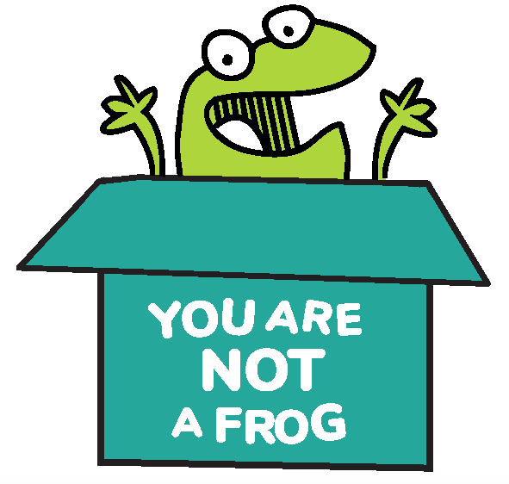
You Are Not A Frog

Workbook, CPD & Reflection Log

Episode 67: Bringing Your Best Self to Work with Dr Sarah Goulding

For this episode, Rachel is joined by Dr Sarah Goulding, a GP mentor and head of coaching at the Joyful Doctor. She is a training program director and author of Shapes Toolkit Trainer.

Dr Sarah first discussed how she managed from experiencing burnout to coaching and mentoring doctors. She shared the helpful resilience and productivity tools that transformed the way she approached work. Finally, we will consider the importance of finding a career that suits us rather than trying to slam round pegs into square holes.

Podcast links
- Resilient Team Academy  - You Are Not A Frog Ep. 41: Dame Jane Dacre  - You Are Not A Frog Ep. 54: Dr Surina Chibber  - You Are Not A Frog Ep. 62: Dr Karen Castille, OBE | - VIA Character Strengths Survey  - StrengthsFinder 2.0  - Simon Sinek: How great leaders inspire action | TED Talk  - Start With Why by Simon Sinek  - Connect with Sarah: Website | Twitter Instagram | Linkedin | - Sign up here for more FREE resources.  - Join the Shapes Collective Facebook group  - Email Rachel or reach her on LinkedIn or Twitter.

QUOTE TO REMEMBER:

‘Just because somebody else might be choosing to live life unhappily and exhausted does not mean that we have to make the same choices because we have our interests and values that bring us purpose’.

What You Will Learn from the Activity

You might feel like who you are at work is a completely different person from who you are at home. Do you feel unfulfilled when you clock out? Does your job feel joyless, or do you feel overworked? It might be time to take a step back from your life to reexamine who you are and what you value.

This workbook serves as a tool on how doctors and busy professionals beat burnout and work happier. It will push you to reflect on what you should change and what you should keep in your personal and professional life. Also, it will teach the importance of finding your core strengths and placing them in your work.

Your work doesn’t have to be drudgery day in and day out. By rediscovering your personal values and evaluating your core strengths, you can turn your work into the joyful activity that it should be. Now is the time for you to re-evaluate your life so you can do what you love. So take notes!

Activity: How Can You Bring Your Whole Self to Work and Still Be Happier?

How do I identify if I am getting burnt out?

How is getting burnt out different from feeling tired?

What am I using to measure myself in terms of my work?

In the space below, list down what you personally value. In the next column, list what it is that your job values. Do the two columns align? If not, what can you do to make your job align with your personal values?

Personal values | Career values

When was the last time I felt fulfilled and happy? What made me feel that way?

What else would help me to live and work more consistently with my values? What other help do I need?

CPD time claimed:

For more episodes of You are not a frog, check out our website www.youarenotafrog.co.uk follow Rachel on Twitter @DrRachelMorris and find out more about her online and face to face courses on surviving and thriving at work at www.shapestoolkit.com.

