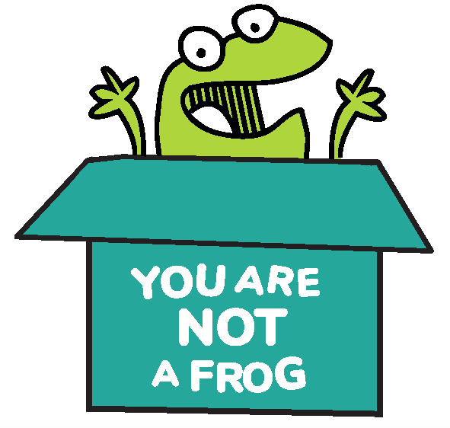
You Are Not A Frog

Workbook, CPD & Reflection Log

Episode 68: Breathing Techniques to Beat Stress with Richard Jamieson

In this episode, Rachel is joined by Richard Jamieson, an entrepreneur and a life coach working in South Africa. He is a leadership coach who uses breathing techniques to help his clients with stress management.

Richard explains the power of breathing to beat stress. He emphasiss that breathwork is more accessible than meditation, so it can be done anytime and anywhere you are. Three tips are suggested as the core of his breathing exercise: awareness, regulation, and transformation. These core values of breathing could give us 5 effective breathing techniques in reducing stress.

Podcast links
- Richard’s website  - Breath by James Nestor  - Just Breathe by Dan Brulé | - Listen to Deepak Chopra on Waking Up to Your Full Potential in Feel Better, Live More with Rangan Chatterjee  - Sign up here for more FREE resources. | - Join the Shapes Collective Facebook group.  - Email Rachel or reach her on LinkedIn or Twitter.

QUOTE TO REMEMBER:

‘The vicious cycle can be turned into a virtuous cycle bringing you to mindfulness. It is when some part of you has recognised that you need to slow down your breathing’.

What You Will Learn from the Activity

Are there times that you just can’t control your breath when you felt anxious and pressured? Does it feel like you just want the stress to be gone in a blink of an eye? Maybe you could re-examine how you face these stressful situations. Have you tried calming yourself down through breathwork?

This workbook can help you enhance your stress management by introducing breathing techniques. To remember how to use your breathing to destress, keep the acronym ART in mind. This stands for awareness, regulation, and transformation. First, you must be aware of your breath, notice its minute details. As you get to be more mindful, practice coherent breathing. Lastly, start exploring. There are different breathing patterns and techniques that you can experiment on.

How to Use Breathing to Reduce Stress

- Observe your breathing: The first step in breathing is becoming aware and observing the mechanisms of your breath. Are you breathing rapidly or slowly? You’ll also feel your environment as you become more observant.
- Coherent breathing: Breathe slowly and steadily. Inhale to a count of 5 or 6 then exhale to another count of 5 or 6. If this is too difficult, you can start with 1or 2counts, then slowly start to increase.
- Constantly check your breathing: You can set a reminder on your phone, Apple Watch, or any gadget that can prompt you to check on the state of your breathing. Set aside some time in your day to practice breathing to bring you into a more balanced state.
- Explore more resources: Richard shared that there are different workshops and books you can check out to help you learn more on which best applies to you.

Start destressing by trying out these tips!

Activity: How to Use Breathing Exercises to Calm Down

Close your eyes. Think of a stressful scenario you have recently encountered. As you envision that scenario, observe your breathing. After taking note of this, start practising coherent breathing. Try to maintain a slow, steady breath. Inhale for 5 to 6 counts, then exhale for 5 to 6 counts.

- What situation have you imagined while you closed your eyes and performed the exercise?

- What did you learn after paying attention to your breathing?

- How did you feel after making a conscious effort to breathe slower?

Now, close your eyes again and try to imagine yourself in your dream vacation. Inhale for 5 to 6 counts, then exhale for 5 to 6 counts. Do this repeatedly for 3 minutes.

- Were you able to view a very relaxing scene as you do this breathwork?

- Did the exercise fuel the calmness in you?

- How can you apply this exercise to your daily life?

CPD time claimed:

For more episodes of You are not a frog, check out our website www.youarenotafrog.co.uk follow Rachel on Twitter @DrRachelMorris and find out more about her online and face to face courses on surviving and thriving at work at www.shapestoolkit.com

