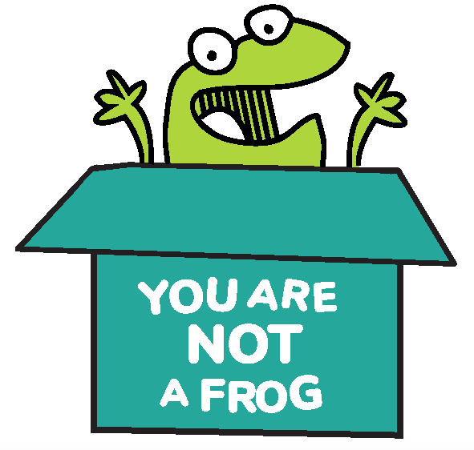
You Are Not A Frog

Workbook, CPD & Reflection Log

Episode 84: Complaints and How to Survive Them Episode 4: Creating a Workplace Where It's OK to Fail with Prof Susan Fairlie and Dr Jane Sturgess

In this episode, Prof Susan Fairlie and Dr Jane Sturgess join us to share their thoughts on speaking up in the workplace.

They give us valuable insights on changing a workplace culture that does not allow us to fail, and prevents us from having difficult conversations. They shed light on the numerous challenges we face regarding speaking up at work. Crucially, they talk about the importance of having an environment that encourages failing fast instead of failing big. We also touch on the topic of incident reports and why we need to submit them.

It’s okay to speak up! Learn how feedback and having honest conversations are valuable to you, your organisation and your patients.

Podcast Links  - Permission to Thrive CPD membership  - Medical Protection  - Dental Protection  - E78: Preparing to Fail Well with Drs Sarah Coope, Annalene Weston and Sheila Bloomer  - E80: What to Do When You Make a Mistake with Drs Clare Devlin and John Powell  - E82: Surviving the Process with Drs Jessica Harland, Caroline Walker and Heidi Mounsey  - Chaos in the Clinic by Perez HR, Beyrouty M, Bennett K, Baier Manwell L, Brown RL, Linzer M, Schwartz MD | - Civility, Respect, and Engagement in the Workplace (CREW) Study  - Civility Saves Lives  - Mastering Civility: A Manifest for the Workplace by Christine Porath  - Clinical Human Factors Group  - Nancy Kline books  - Freedom to Speak Up campaign  - Learning from Deaths  - The Fearless Organization by Amy Edmondson  - Developing cultures of high-quality care by Michael West  - The Happiness Advantage by Shawn Achor  - Radical Candor by Kim Scott | - Amy Edmondson’s Twitter  - Vital Conversations by Alec Grimsley  - Fierce Conversations by Susan Scott  - Compassionate Conversations by Diane Musho Hamilton, Gabriel Menegale Wilson, and Kimberly Myosai Loh  - Connect with Susan: website  - Connect with Jane: LinkedIn  - Sign up here for more FREE resources.  - Join the Shapes Collective Facebook group.  - Email Rachel or reach her on LinkedIn or Twitter.

QUOTE TO REMEMBER:

‘Let's demonstrate that it is okay to speak up. So I think the trust will come from when people see that they're being taken seriously.’

What You Will Learn from the Activity
Everyone makes mistakes, even healthcare professionals. Whilst they are common, they shouldn’t be concealed or ignored. Instead, they should be addressed and become grounds for improvement.

This activity will help you realise the importance of incident reporting and difficult conversations by reflecting on their profound impact on workplace culture and patient safety.

We also go through the negative connotations we often associate with terms like mistakes, near misses, near hits, and incident reporting. In addition, this activity aims to help you change your mindset when it comes to filing incident reports, as well as gain valuable insights on how you can make tricky yet vital conversations with your team more bearable.

It's better to fail fast and early than to fail later with more significant consequences.

Activity: Speaking Up at Work

Think about the culture at your workplace. Do you feel that you’re in an environment where you can speak up? Are you allowed to challenge your colleagues and superiors?

If not, what could you do about it?

Toxic workplaces have higher staff turnover and more errors. How do you think your work environment is affecting your performance?

Recall instances where you were afraid or anxious to have a difficult conversation with a colleague. What would you do differently next time?

Are there any models discussed in the podcast which would help you give and receive feedback better? Describe the model and reflect on how you could apply it in your workplace interactions.

Are there any other ways in which you could improve how you give feedback to your colleagues?

List down the ways you could address any transparency and honesty barriers due to hierarchy. What did Susan and Jane do so that their juniors would speak up? Which of these can you do and which can you not?

1.
2.
3.
4.
5.

How do you differentiate between niceness and kindness? How can you become more kind in your workplace?

Many organisations forego or even weaponise incident reports. However, these can be powerful sources of information and learning. Do you have fears and anxieties about incident reporting? How can you overcome these?

What could your organisation do differently so that incidents and ‘near hits’ become a crucial way of learning?

Lack of trust is one of the barriers to transparency within a team. How could you build trust amongst your team?

CPD time claimed:

For more episodes of You are Not a Frog, check out our website www.youarenotafrog.co.uk follow Rachel on Twitter @DrRachelMorris and find out more about her online and face to face courses on surviving and thriving at work at www.shapestoolkit.com.

