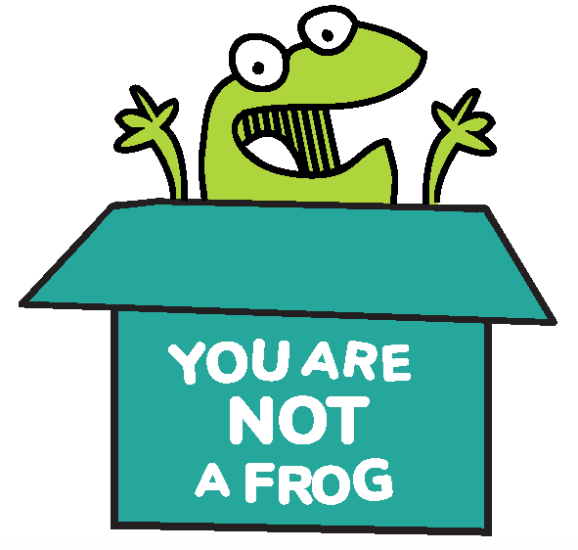
You Are Not A Frog

Workbook, CPD & Reflection Log

Episode 62: Self-Coaching for Success with Dr Karen Castille, OBE
For this episode, Rachel is joined by Dr Karen Castille, OBE, an accomplished healthcare leader with more than 30 years of NHS experience. Karen is also a leadership and performance coach. Rachel and Karen talk about how we can take control of our lives and help ourselves get unstuck without having to spend time and money on coaching. She also explains why getting advice from other people often just doesn’t work.

Karen delves deeper into the process of self-coaching and how we can fit it into our weekly routine. She also gives us her top tips to get us started on our journey.

Podcast links  - Implementing change in the NHS, Karen’s DBA thesis  - The Self-Coaching Workbook by Dr Karen Castille  - Free to Focus by Michael Hyatt  - You Are Not A Frog Episode 54 with Dr Surina Chibber | - Zen Tennis by Dr Joseph Parent  - The Inner Game of Tennis by W. Timothy Gallway  - The Coaching Habit by Michael Bungay Stanier  - Karen’s website  - Connect with Karen: Twitter | Email | Email | - Sign up here for more FREE resources.  - Join the Shapes Collective Facebook group.  - Email Rachel or reach her on LinkedIn or Twitter.  - Find out more about the Permission to Thrive CPD club for doctors

QUOTE TO REMEMBER:
‘Self-coaching is a mindset of trying to ask yourself some key questions when you have a dilemma, or a challenge, or problem to help you work your way through it in a structured way. But it's difficult. It's a skill — and skills take time to learn. So it's practice, practice, practice that gets you better at it’.

What You Will Learn From The Activity

Do you have moments in your life when you feel stuck and would like to figure out what to do next? Do you wish you regularly had the time to think things through? Seeking help from a coach does not sound like a bad idea, but what if you don’t have the time and resources for this?

Self-coaching is the answer.

In the episode, Rachel and Karen explore the power of self-coaching and crafting your own questions to create transformational change in your life! This workbook aims to help you get started on your journey and help you understand how self-coaching can be advantageous in your career and personal life. It also gives you some of the questions you might need to answer to turn your life around.

You don’t have to remain stuck in an unhealthy place forever. The answers you seek are within you all along. Self-coaching is a skill, and it will take practice. But eventually, you can help yourself and become the person you always wanted to be.

Activity: The Power of Self-Coaching

What are your key takeaways from this episode?

Explain what self-coaching means. Have you tried it before?

Do you agree with Karen when she mentioned that advice from other people rarely works for adults and that we learn more by thinking and doing? Why or why not?

What are some of the reasons why people don't work with a qualified coach?

Before you begin with self-coaching, can you identify the areas in your life where you feel stuck and would like to figure out what to do next? Reflect on everything that has been bothering you. Write down those dilemmas and jot down all the questions you have about them.

Spend 10 minutes or more writing down the answers you have. Take all the time you need. (The asterisks indicate questions that Karen gave in the episode. You may add more questions or rewrite them to fit your circumstances.)

*What are you trying to achieve? What outcome are you looking for? What's the end goal and the vision you want to get to?

*What does success look like to you?

*What's in your control and what isn't?

*What is it about your current situation that's making you feel whatever it is that you're feeling?

Karen talked about how we catastrophise our problems, escalating them to a level higher than they really are. Do you do this? How can self-coaching help you avoid catastrophising?

Why is commitment vital in self-coaching?

Making a solid, non-negotiable appointment with yourself is crucial in the success of self-coaching. Make an appointment with yourself below. Indicate the days when you will find time to reflect and ask yourself important questions about the things that have been challenging you.

Karen also talked about the aspiration-challenge-experience framework. When it comes to coaching or even self-coaching, why should you avoid focusing solely on challenges?

People often find themselves unable to stick with their New Year goals because they frame them negatively. With that in mind, what are your goals for this year?

After listening to the episode, do you think you can begin self-coaching and commit to it? How can Karen’s top tips help you?

CPD time claimed:

For more episodes of You are not a frog, check out our website www.youarenotafrog.co.uk follow Rachel on Twitter @DrRachelMorris and find out more about her online and face to face courses on surviving and thriving at work at www.shapestoolkit.com.

